* **Maor Bemdoo ------------------------ BHU/23/04/05/0068**
* **Elias Esther ------------------------ BHU/23/01/07/0044**
* **Stephenie Bitram Boyi----------------------- BHU/23/04/09/0074**
* **Ibrahim Daniel ------------------------ BHU/23/04/05/0076**
* **Adamu Jighjigh ------------------------ BHU/23/04/09/0080**

**THE FOODIE APP**

**COS 101 PROJECT ASSIGNMENT**

2024

**THE FOODIE APP**

**Brochure**

**Definition:**

The foodie app is a user friendly and efficient desktop application designed to make food preparation easy and more efficient through provision of simple to complex recipe in a simplified manner.  
  
**Features:**

* Food search varieties
* food menu recipes

**Technologies:**

* PyCharm
* Library
* Git
* VS code
* API-ninja
* Wikipedia API

**Future features:**

* Account creation system
* Search based suggestions
* Virtual kitchen

**Flowchart:**

**DISPLAY HOW TO PREPARE SELECTED FOOD**

**INPUT FOOD**

**CLICK BUTTON OF A SPECIFIC FOOD**

**FLOW CHART**

**IF FOOD IN API**

**DISPLAY FOODS**

**App showcase:**

**LOGO**

**USER INTERFACE**

**SEARCH RESULT(S)**

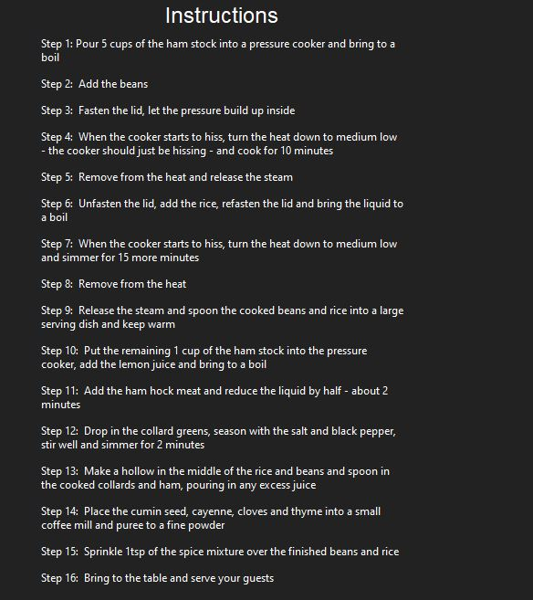

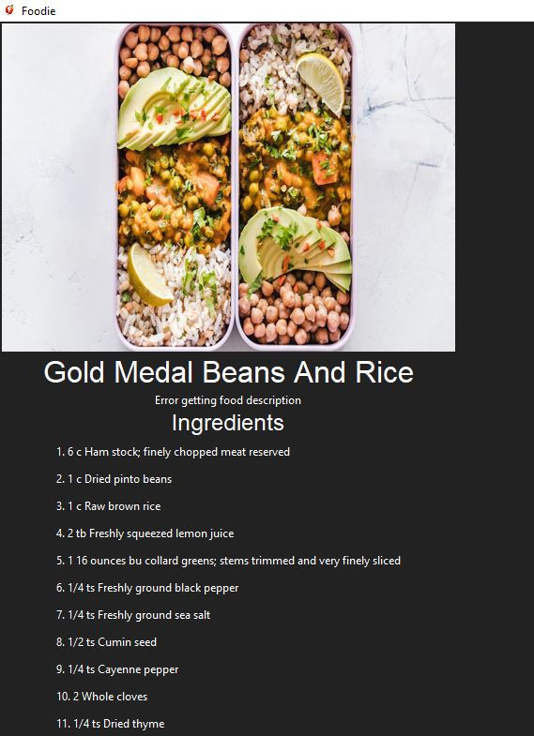

**INSTRUCTIONS**

**INGREDIENTS**

**License:**

This project is under MIT Liscence.

**Author(s):**

* Maor Bemdoo ------------------------ BHU/23/04/05/0068
* Elias Esther ------------------------ BHU/23/01/07/0044
* Stephenie Bitram Boyi ------------------------ BHU/23/04/09/0074
* Ibrahim Daniel ------------------------ BHU/23/04/05/0076
* Adamu Jighjigh ------------------------ BHU/23/04/09/0080